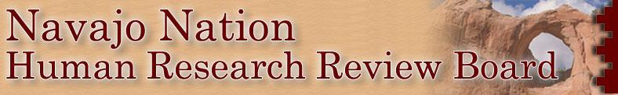
NAVAJO NATION HUMAN RESEARCH REVIEW BOARD MEMBERS
NAME Appointed by Term
Dr. David Begay, Ph.D. – Scientific Education HEHS June 2021 – June 2024
Dr. Rebecca Izzo-Manymules, Ph.D., MPH, Chair Education HEHS June 2021 – June 2024
Dr. Kalvin White, Ph.D. - Scientific Education HEHS June 2021 – June 2024
Dr. Sonya Shin, MD – Medicine NN President Jan. 2024 – Jan. 2027
Dr. Nanibaa’ Garrison, Ph.D – Genetics, Bio-Ethnics NN President Jan. 2024 – Jan. 2027
Delvin Yazzie, MPH - Epidemiology NN President Jan. 2024 – Jan. 2027
Dr. Christopher Jentoft, MD – Medicine NAIHS Jan. 2024 – Jan. 2027
Dr. Paul Carlton, MD. – Medicine NAIHS Jan. 2024 – Jan. 2027
Paula R. Mora, MD – Public Health NAIHS Jan. 2024 – Jan. 2027

Enabling Legislative
The Navajo Nation Human Research Review Board was developed in1996 to guarantee ethical research for the Dine´ People.

Purpose: The purpose of this Code shall be to set forth the conditions under which investigators, physicians, researcher and other may perform heath and health related research activities within the territorial jurisdiction of the Navajo Nation;

Policy: It is the policy for the Navajo Nation to ensure that all persons within the territorial jurisdiction of the Navajo Nation are free from unreasonably harmful, intrusive ill-conceived or otherwise offensive research and investigation procedures.
- Navajo Nation Council 13.N.N.C. §3253 Health and Welfare;
- Chapter 25. Navajo Nation Human Research Code (section 3251 – 3271)
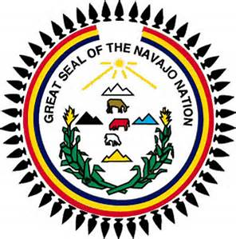
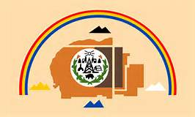
- Navajo Nation Human Research Review Board and Navajo Area I.H.S. IRB , FWA Certification #IRB00000641 (2024-2027)

